User Requirement Specification (URS)
Vending Machine Control System (VMCS) Computer Simulation
Document Reference: |  | ISS/VMCS/TR.1/V2.0
Project: |  | VMS
Document Title: |  | Volunteer Management System User Requirement Specification (URS)
Version: |  | 1.0
Author: |  | Team 08
 | © 2001  The information contained in this document is the property of ISS. The contents must not be copied in whole or in part for purposes other than which it has been supplied without the consent of ISS, or, if it has been furnished under contract to another party, as expressly authorised under that contract, then ISS shall not be liable for any errors or omissions. | 
Institute of Systems Science, 25 Heng Mui Keng Terrace,
Singapore 119615

Version History Record
Version | Review & Approval Form Number | Date | Brief description of amendments and affected pages, paragraph
1.0 | ISS/VMS | 19/03/11 | First Issue

Table of Contents
1. INTRODUCTION 4
1.1 Background 4
1.2 Objectives 4
1.3 Organization 4
1.4 Scope 4
1.5 Definition of Terms 4
2. OVERVIEW OF REQUIREMENTS 5
2.1 Introduction 5
2.2 System Perspective 5
2.3 System Functions 5
2.4 User Characteristics 6
2.5 General Constraints 6
3. FUNCTIONAL REQUIREMENTS 7
3.1 Processing Requirements 7
4. OPERATIONAL and Quality REQUIREMENTS 14
4.1 Operating Environment 14
4.2 Development Constraints 14
4.3 Performance 14
4.4 Reliability 14
4.5 Availability 14
4.6 Capacity and Expandability 14
4.7 Security 14
4.8 Future Growth 14

INTRODUCTION

Background
The consulted organization is poverty elimination NGO. It has grown tremendously over the years and is attracting more and more volunteers both domestically and internationally. As it grows, there is an increasing need to coordinate and manage its volunteers, especially international volunteers as they require more administrative and logistic efforts. The current ways of manually handling documents and volunteers requires a lot of works and limiting the organization efficiency.
From the situational analysis and problems identified, our team proposed an integrated system with the aim of addressing the problems of volunteer communication, documentation, recruitment and retention.

Objectives
The objectives of this document are to:
- define the functional requirements for the VMS
- define the non-functional (i.e. operational and quality) requirements that would be necessary to support the functional requirements
- define the operational environment of the system.

Organization
Section 1 gives an introduction to this document.
Section 2 presents an overview of requirements for the system.
Section 3 presents the functional requirements and
Section 4 describes the operational and quality requirements.

Scope
This user requirement specification is solely concerned with the development of the VMS.

Definition of Terms
The following terms have special meanings within this document:
- The word shall imply a mandatory requirement.
- The word should imply a desirable requirement.
- The word will imply a mandatory requirement outside the scope of this document.
- The word may imply a desirable requirement outside the scope of this document.

OVERVIEW OF REQUIREMENTS

Introduction
The Volunteer Management System operates and maintains a large number of volunteer information and project information. Previously, this information is controlled manually. With the fast organization growth, it is very difficult to maintain and manipulate all the information manually and the organization has been decided to move to a computerised control system that will be access through intranet and internet.

System Perspective
The VMS allows the volunteers to register their own account, let them post the feedback to the project based on their experience and idea and sharing their inspiring stories and experience, etc...By providing such features will support the fast growth of organization with different insight and knowledge from different people. It also allows the internal staff to maintain the project related information such as project details, itinerary plan, project calendar, project member, etc... and reporting features which will describe the required summary and detail information.

System Functions
System functions to be implemented are:
Volunteer Management
- Register Volunteer Account
- Update volunteer profile
- Reset Password
- Change Password
- Browse for Projects
- Post Feedback to Project
- Share Experience and Inspiration stories
- Raise Interest to Project
- Send Request for Certificate
- Manage Volunteer Account
Staff Management
- Register Staff Account By Admin
- Update Profile By Staff
- Reset Password
- Change Password
- Manage Staff Role
- Manage Staff Account
Project Management
- Propose Project
- Approve/Reject Project Proposal
- Set-up Project Details
- Invite Volunteer by Email
- Assign Member and Roles
- Set-up Itinerary Plan
- Set-up Project Calendar
- Update Project Progress
Itinerary Management
- Prepare Itinerary Plan
- Submit Itinerary Plan
- Approve/Reject Itinerary Plan
- Set up Itinerary Plan
Reporting
- Project Tracking Report
- Volunteer Specific Report
Certificate Management
- Upload Certificate Template
- Request Certificate By Volunteer
- Generate Certificate
- Print Certificate
System Control Panel
- Configure System Parameters

User Characteristics
For each project, the volunteer can play the following roles:
- acting as the project leader, who will manage a specific project (or)
- acting as the project member
The Internal Staff can play the following roles:
- acting as the Project Manager, who will manage one or more projects (or)
- acting as the system administrator, who will manage staff account (or)
- acting as the Administrator, who will manage volunteer account, generate report and certificate
Each Volunteer and Internal Staff can play more than one role.

General Constraints
Dio: Existing hardware and software resources shall be used for this project. No additional resources shall be provided.
Development team can use any third party components to build.
Change to requirements will have to go through Change Management Process (Which will be defined in Quality Plan)

FUNCTIONAL REQUIREMENTS
This section describes the functional requirements of the VMS. The functional requirements are structured in terms of:
- Processing requirements – the main software functions to be provided to achieve the VMCS computer simulation.
- User interface requirements – the required user interface to support the software functions.

Processing Requirements
The system is required to provide the software functions necessary for the application to manage volunteer and project information and for the volunteers and internal staff to perform their roles in using the system. These functions are described in the following subsections.

Volunteer Management
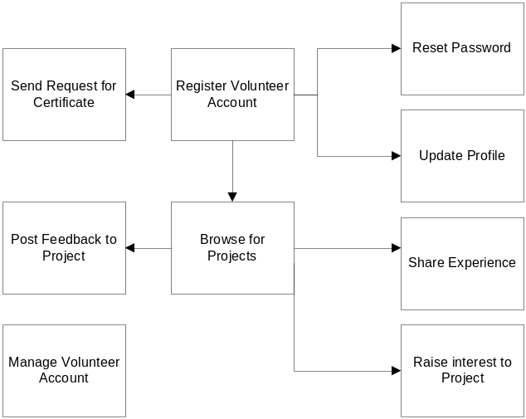

Volunteer Management Business Flow Overview
Dio: Please indicate the start point and the end point of the flow, together with numbered steps- easier to read, and who should be in charge of which steps / flow

Register Volunteer Account
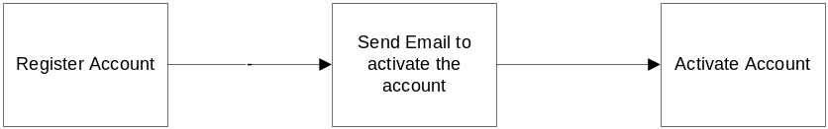
- The volunteer shall register the volunteer account by entering the email and password.
- The system shall create the account and send the notification email to the volunteer email’s address
- The volunteer shall activate the account by clicking the link in the email from the VMS system.

Update Volunteer Profile
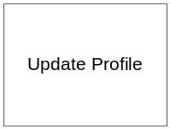
- The volunteer can update their own profile.
Dio: How to start this process? Should we have : Start updates → Confirm update profile → Result?

Reset Password
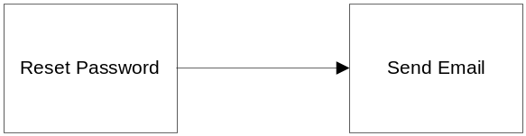
- The volunteer can reset the password and the system will send the reset password via email.
Dio: how to start this process? Should we have start point and end point?

Change Password
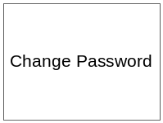
- The volunteer can change his or her preferred password at any time.
Dio: Similar to Update Profile process: should we have Change password → Confirmation → Notification of result?

Browse for Project
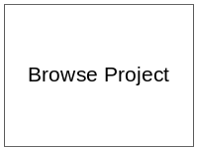
- The volunteer can browse the list of projects and the project they joined.
Dio: Similar, should we have start point and end point for each process/workflow?

Raise Interest to Project (Dio: or Indicate interest in projects)

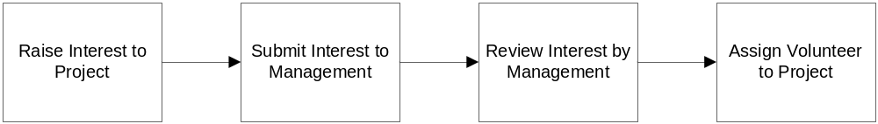
Dio: should we have 2 different flows?
  - Flow 1: Search Project” → Indicate Interest/preference in this project
  - Flow 2: Project Manager review volunteer profile & preference → Perform Assessment → Assignment result (accept/not accept) → Volunteer acknowledge → End
- Volunteer can send the request to project manager for the project that they are interested in and that they want to join.
- The Project Manager or Project Leader will review and assign the requested volunteer to the project in high priority.
Dio: can we have different assessment result (i.e.: accepted/rejected)?

Post Feedback to Project

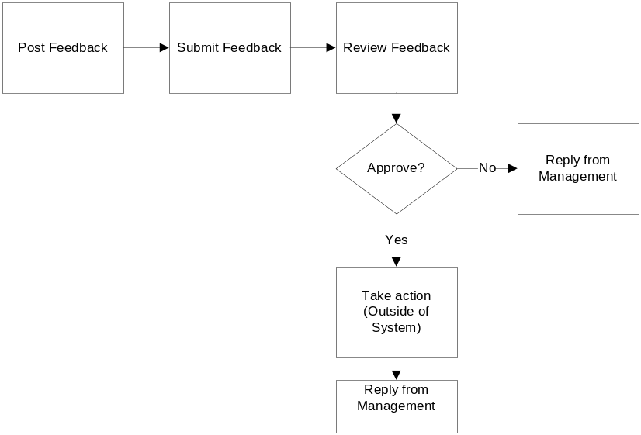
- Any Volunteer can post or advice feedback/suggestion regarding to a project and submit to the Project Manager.
- The project manager will review with the management team and reply the volunteer for his posting.

Send Request for Certificate
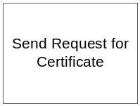
- The Volunteer can request the certificate for the project he/she joined before.
- The certification will be generated by the administrator staff.
- It will be signed by authorized person and it is outside of the system.
- The collection or sending the certificate is also outside of the system
Dio: Then the workflow should be : Send request → Admin verified request → Generated Certificate → Print Cert (offline) → Send to volunteer.

Manage Volunteer Account
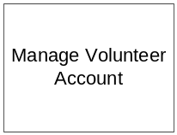
- The administrator staff can manage the volunteer information
Dio: Should specify what action can do: Activate/deactivate/update details – name/password/DOB?...etc. Furthermore each process should have start point and end point: Manage volunteer account → Acknowledge results

Staff Management

Register Staff Account
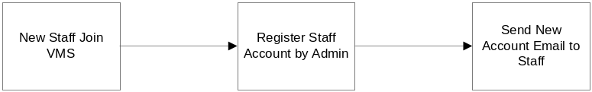

- When new staff joins organization, if he/she needs to access VMS, System Administrator shall register account for new staff.
- Then System will send notification email to staff with user name and password to access VMS.

  - Update Profile by Staff

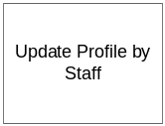

- Staffs who have account can update their profiles.
Dio: Should have flow such as : Update profile → Acknowledge the result (either confirm by email or just display a message on screen)

  - Reset Password

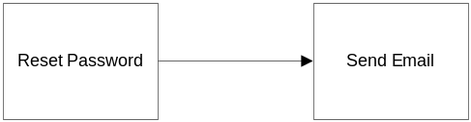

- Staff can reset the password and the system will send the reset password via email.

  - Manage Staff Role
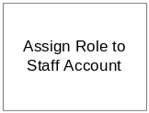
- System Administrator can assign role to staff account.
Dio: should have flow : Assign role → Inform Staff of new role + inform admin

  - Manage Staff Account
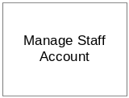
- System Administrator can manage staff account.
Dio:Same as Manage Volunteer Account:
Should specify what action can do: Activate/deactivate/update details – name/password/DOB?...etc. Furthermore each process should have start point and end point: Manage staff account → Acknowledge results → End

Project Management
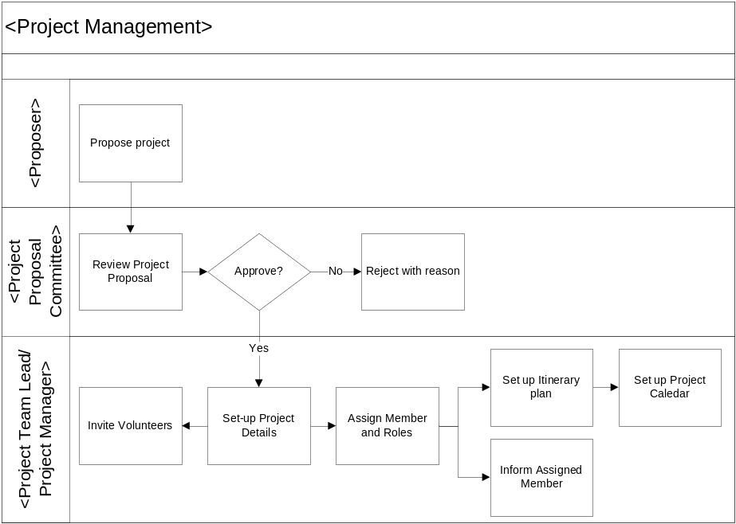
Dio: This is good sample ☺, Volunteer Management should have the same details level – i.e. who in charge of what process, and the flow.
Refer to Unit 3 - workflow sample
Any Volunteer or Staff can propose project.
After receiving project proposal, project proposal committee will review project proposal details and gather necessary information for project proposal approval process.
Dio: Project proposal committee got any account? If not how Project proposal committee approved proposal?
If the project proposal is approved by project proposal committee, project team lead or project manager invite volunteers who are active to join that approved project.
At the same time, project leader or project manager will set up project details.
After these two steps, project leader or project manager can assign members and roles for the project.
Notification email will send to assigned member.
Dio: Did the assigned members have to confirm or by default they’ll be member of the team?
After that, the project leader shall set up itinerary plan (refer: itinerary management).
After itinerary planning is finished, project leader can set up project calendar.
If project proposal committee want to reject the project proposal, they will reject with reason.

Itinerary Management
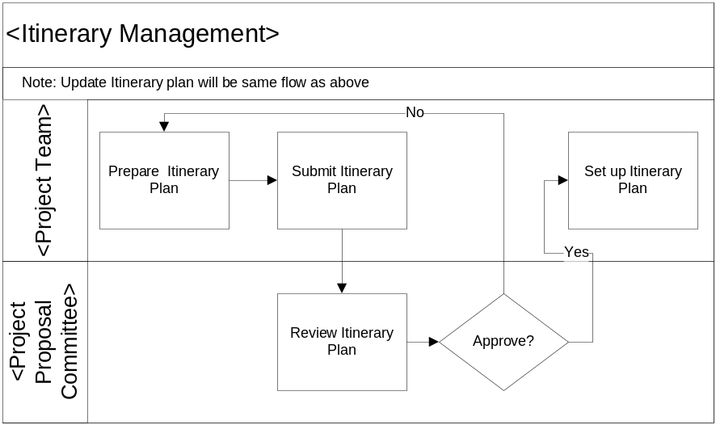
Project Team shall prepare itinerary plan for each project.
After preparation of itinerary plan for project, Project Team shall submit itinerary plan to Project Proposal Committee.
Project Proposal Committee will review the submitted itinerary plan and make decision for approval.
If submitted itinerary plan is approved, Project Team will set up itinerary plan.
If submitted itinerary plan is rejected, Project Team will need to prepare itinerary plan and submit again.

Reporting
Project Manager can generate report for progress of voluntary project or events.
Project Manager can view volunteer-related reports such as how many hours on average a volunteer spend in a project, how many projects such he/she has joined.
Dio: Should have workflow model for Reporting – with start point and end point
And define how many report template we should have. 3 to 5 report templates is good

Certificate Management
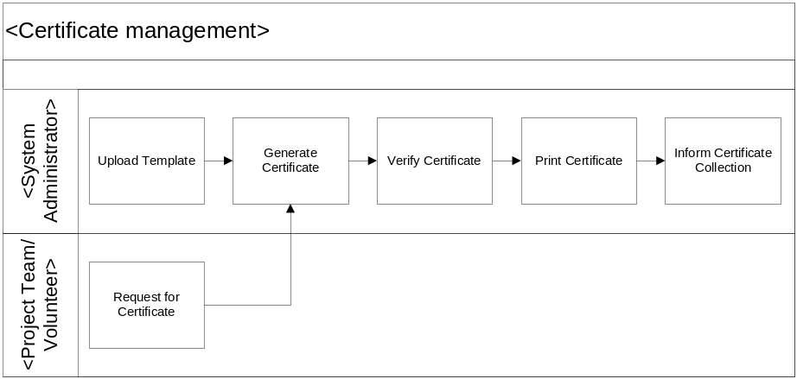
Dio: Can we replace old template? How to remove old template?
System Administrator shall upload certificate template when they want to use the new template.
Project Team or Volunteer can request for certificate.
After receiving the request from Project Team or Volunteer, System Administrator will generate certificate for requestor(s).
System Administrator will verify generated certificate is correct or not.
Then System Administrator will print certificate.
After printing certificate, System Administrator will inform requestor to collect certificate.

System Control Panel
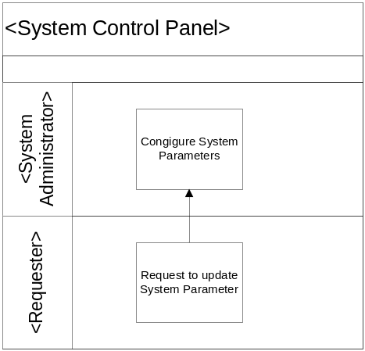

- Requestor can request to update System Parameter.
- System Administrator shall configure System Parameter.
Dio: Who can be requestor? How to send request to Sys Admin
Suggest: Can have 2 workflows:
- Have a screen to raise request for System Parameter, then Sys Admin review
- Sys admin directly goes and change System Parameter.

Logging – Audit
Recommend: all important activities (Create project/modify project/modify System Parameter/ Activate/Deactivate account) should have logging /Audit
Workflow: Performed Action → Record/Audit action
Subsequently, Sys admin can retrieve Audit log/ generate report.

Dio: User Interface Requirement
Web page should be user-friendly? Process with minimal steps required?
No typos, no misalignment.
All page have a common theme – can change themes?
Master page/Common theme will be applied to all major pages, popup page/message page will not needed master page/theme
UI will have to be compatible with most common browser (IE7+, FF3.0+)

OPERATIONAL and Quality REQUIREMENTS

Operating Environment
The system shall operate in Internet and Intranet environment.
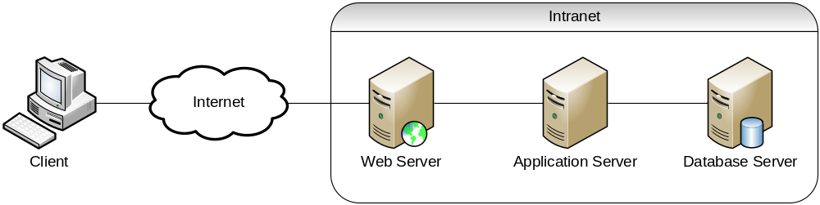

Development Constraints
The software shall be designed using the Rational Unified Process, and shall be coded using the Java programming language.
Dio: would like to put more details: Microsoft SQL Server database, with Tomcat application server? What is server host environment (Windows/Linux)?
What are end-user environment constraints? Browser: Internet Explorer 7+? Firefox 3.0 +?
Please ask Zaw for more input in this part as he’s architect

Performance
The system shall maintain an average of 3 seconds to response to every request from Intranet user or Internet user.
Dio: Have to lower to 5 seconds, as 3 seconds will be quite demanding

Reliability
The combined hardware and software system shall have 99% reliability. In particular during a 24 hour running period the system should not be unavailable for a period longer than 2 hours in total.
Dio: Duplicated with Availability?

Availability
The system shall be available 24 hours a day, 7 days a week with 99% availability per year.
Dio: Quite high, will work out the Architecture design with Zaw but as far as we’re concerned, aim at 90% first.

Capacity and Expandability
The design of the system shall be flexible in order to allow modifiability of the system.

Security
The system should require all users to enter a valid password to logon to the system. Each user will be granted access only to functions that are compatible with their responsibilities.

Future Growth
The VMS should be designed such that only minimal changes are required to modify it to meet the requirements of the volunteer management system.
Dio: Put it in other words (i.e. VMS should be Modular/Component-based/Expandable – Swarna will be very interested to ask us this part)

Appendix

Include all certificate templates / UI template here

